# CS 255 System Design Document Template | Nathan Chuluda

## UML Diagrams

### UML Use Case Diagram

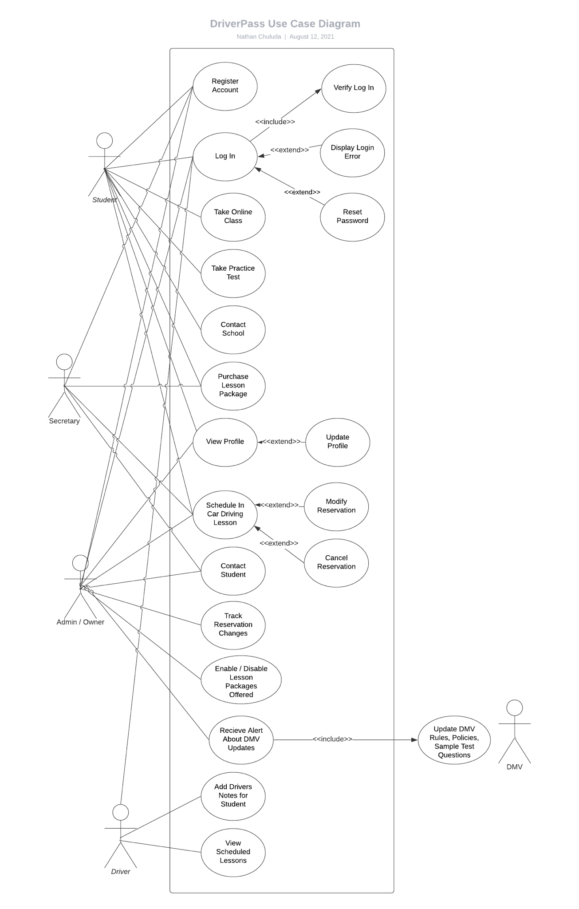

### UML Activity Diagrams

Login:

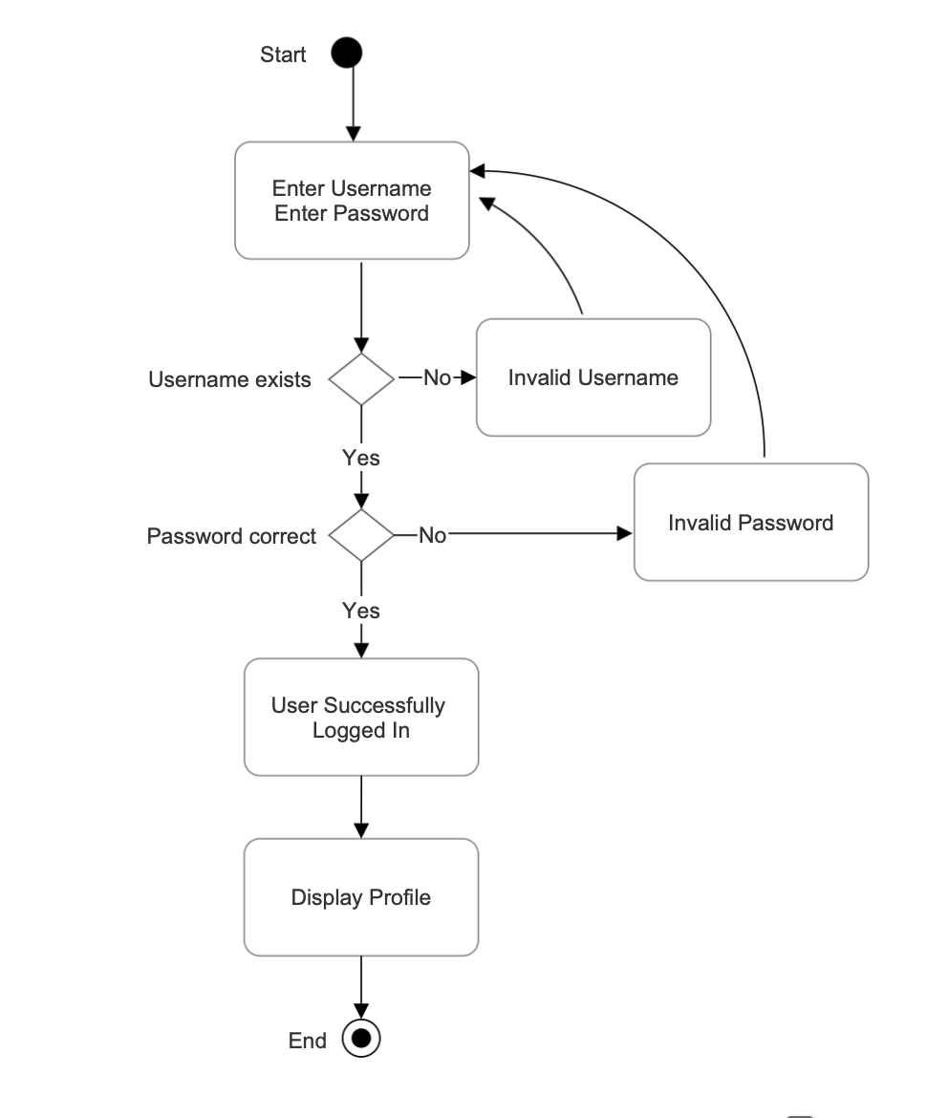

Register:

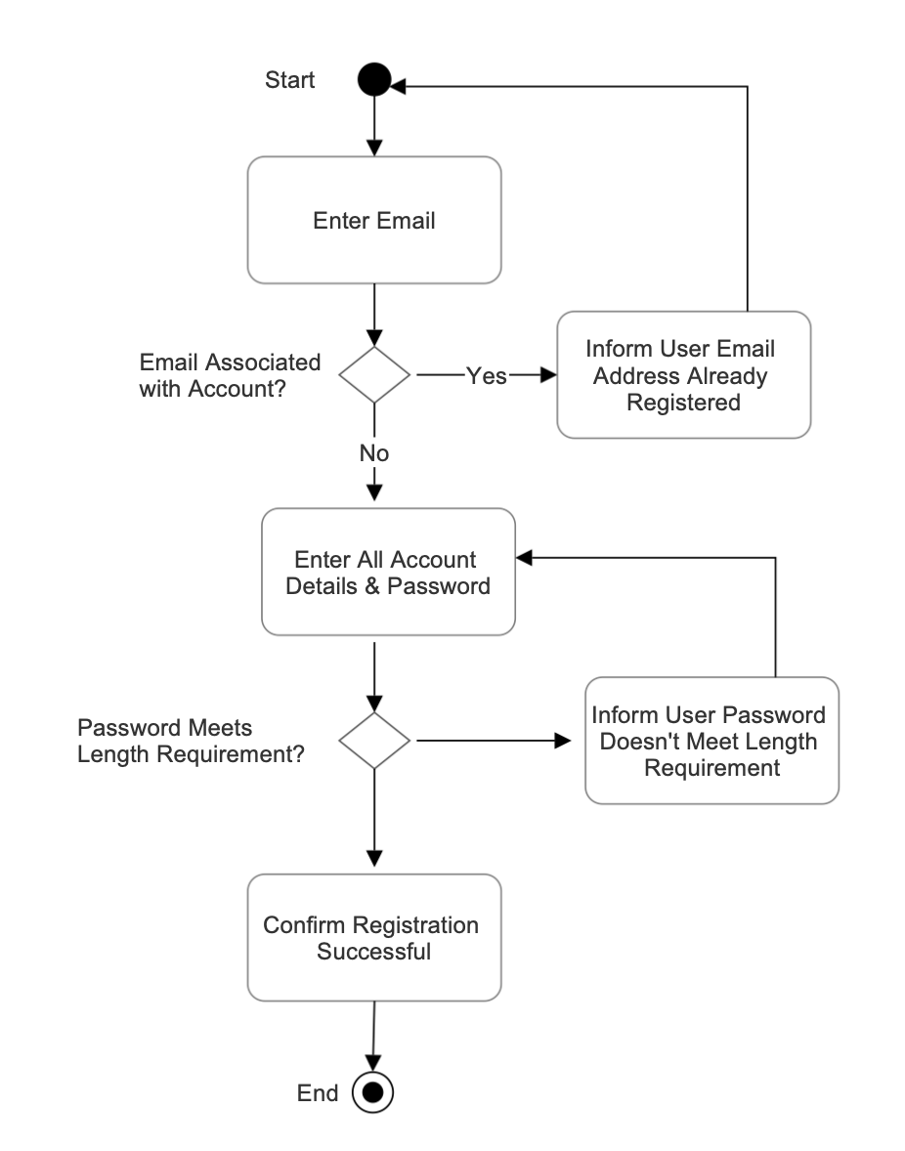

### UML Sequence Diagram

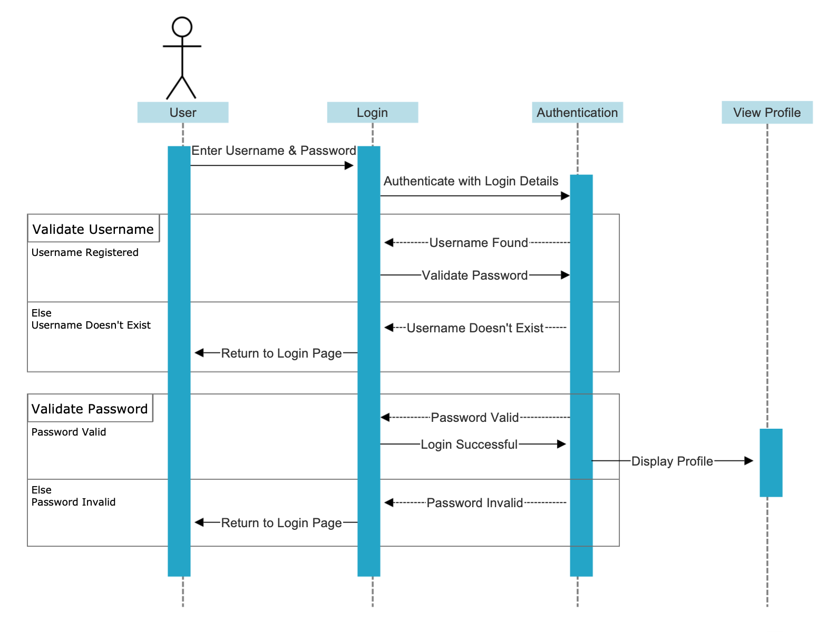

### UML Class Diagram

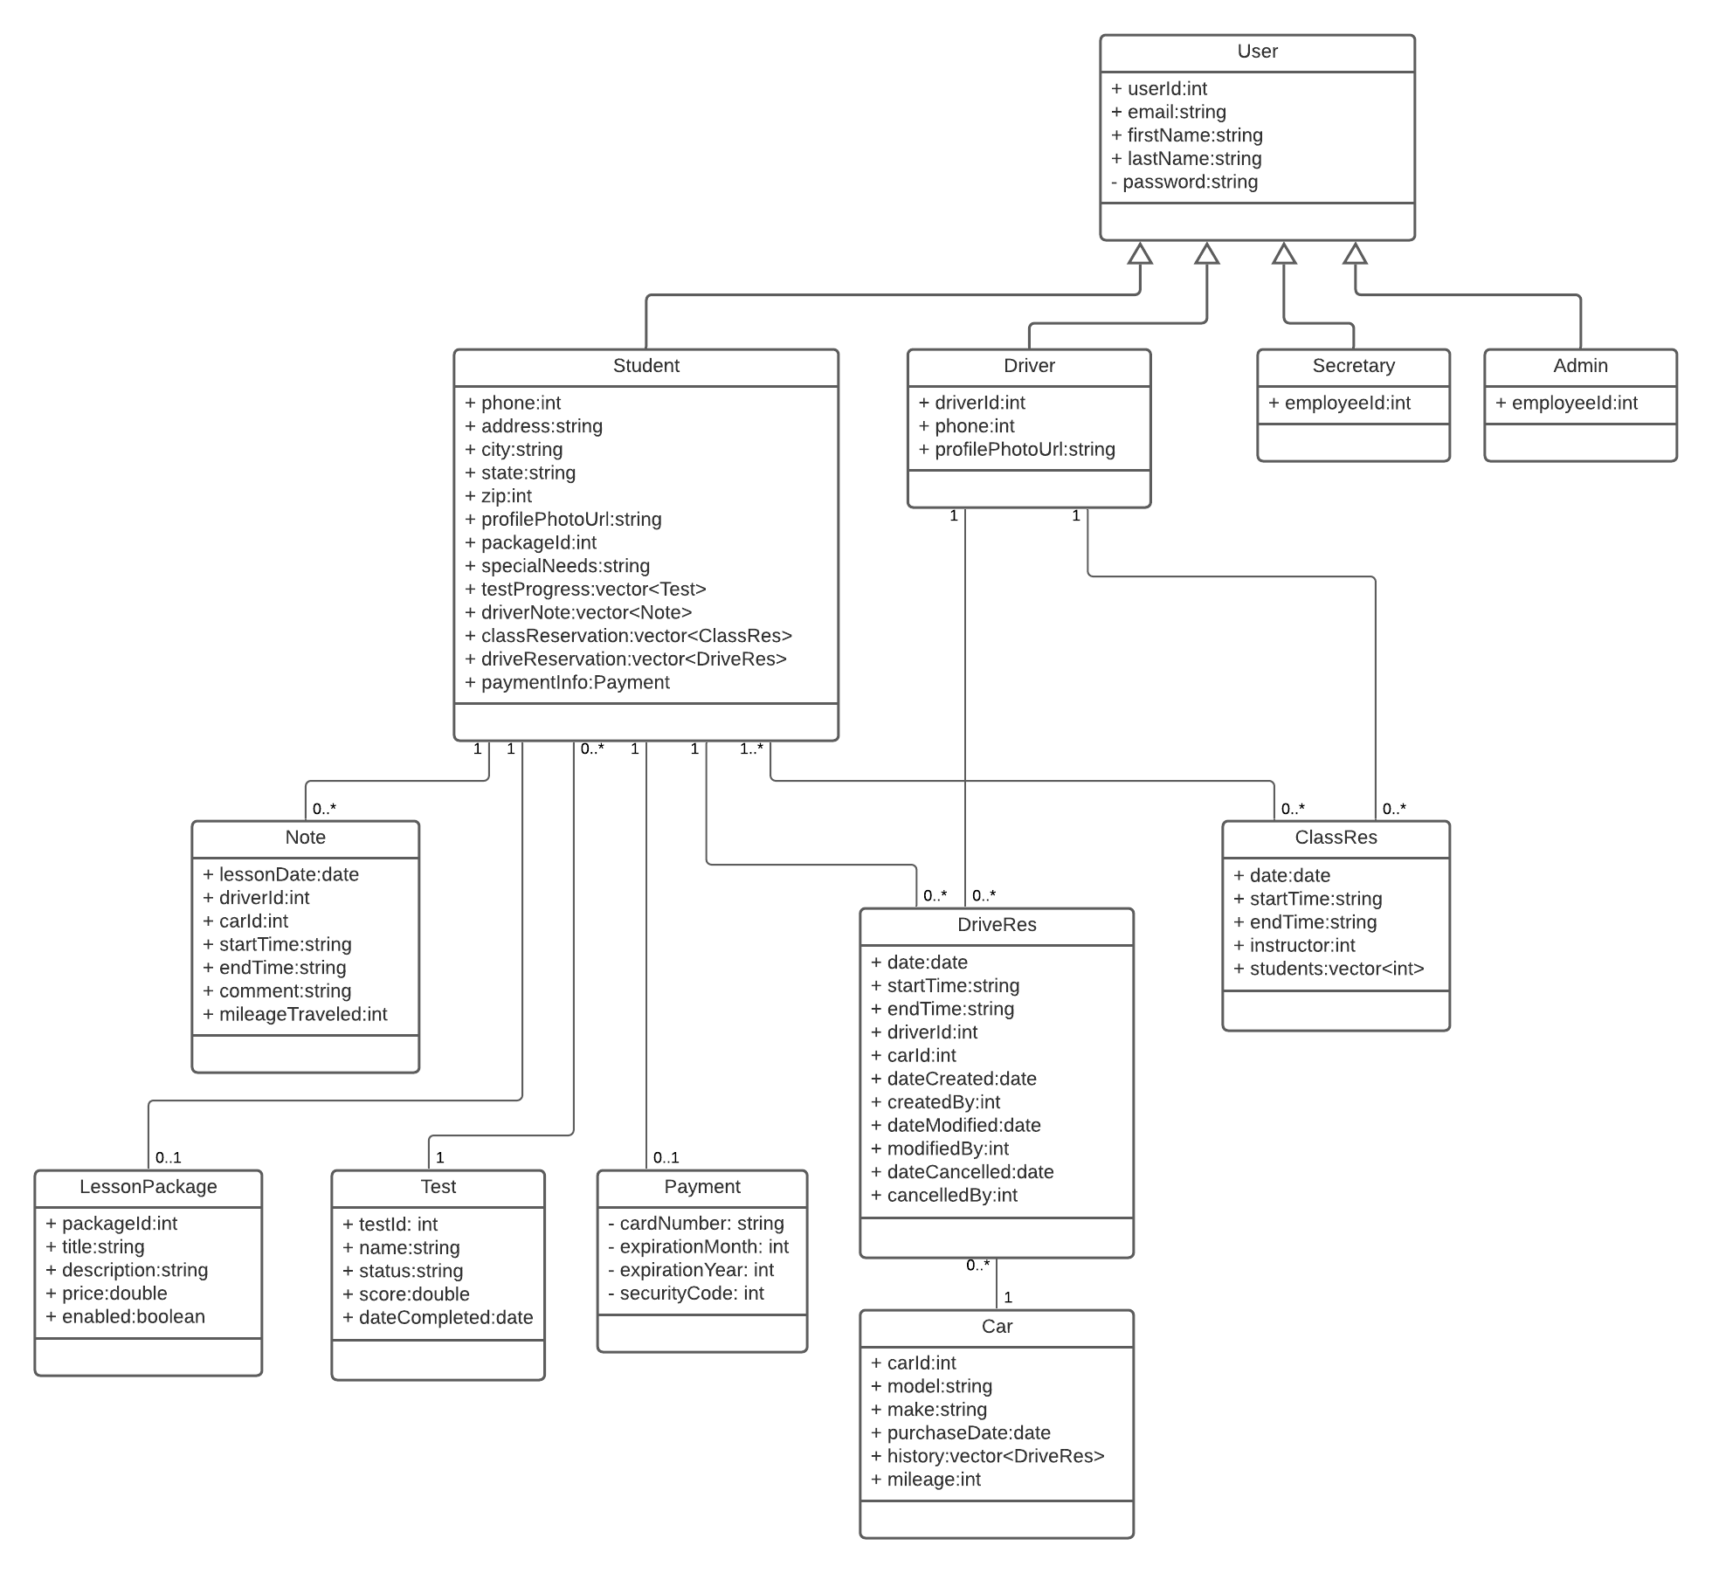

## Technical Requirements

**Hardware:**

* Server for hosting the website, including online lessons and practice tests
* Database for storing user accounts, profiles, online course progress, test results, drivers notes
* Database for storing classroom and in-car lesson reservation schedule
* Desktop or laptop computer for secretary to access website from in the office
* Desktop, laptop, tablet or mobile device for customers to access website from home

**Software:**

* Website for user accounts, profiles, selling lesson packages, making/changing reservations
* Website for online classes and practice tests that saves progress and results to profiles
* Administrator portal for adding employee accounts, tracking changes to reservations, and other privileged/restricted activities

**Tools:**

* Third party payment processing system that integrates into the DriverPass website

**Infrastructure:**

* Internet connection to connect to and interact with website, for both users at home and secretary in the office
* Phone line in office for secretary to be reached at